A2006-Paleo-Eur-England-Northfleet- Figurine-Venus-Flint nodule-c 70,000 BP

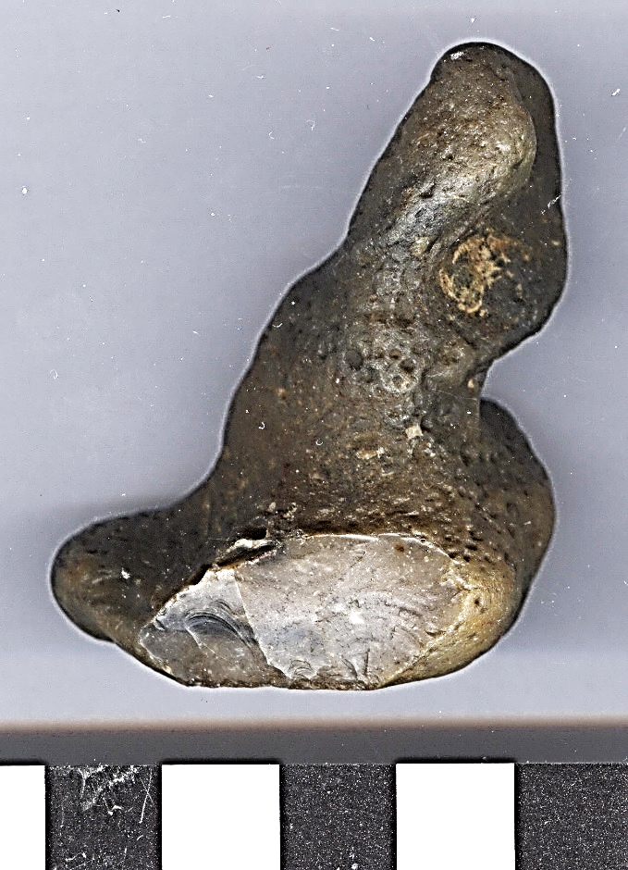 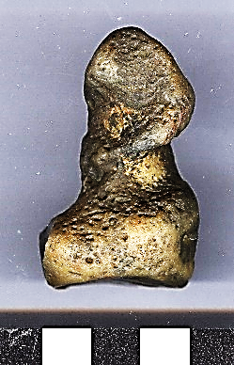 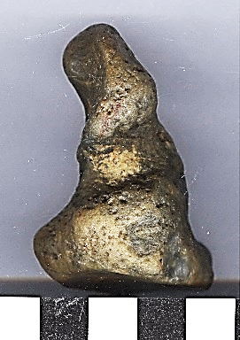

**Formal Label:** England-Northfleet- Figurine-Venus-Flint nodule- c 70,000 BP

**Display Description:**

**Accession Number:**

**LC Classification:** GN772.22.G7

**Date or Time Horizon:** 70,000 BP.

**Geographical Area:** Northfleet near Swanscombe, Kent.

**Map:** from Keith 1916.

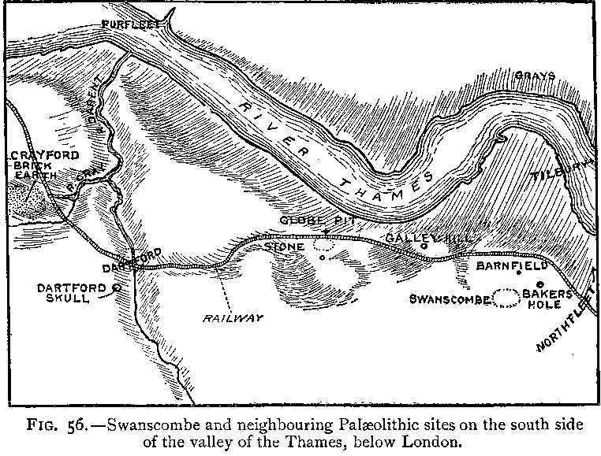

**Cultural Affiliation:** early Upper Paleolithic

**Medium:** flint nodule

**Dimensions:** H 2.03 in, 51.57 mm

**Weight: 2 oz, 60 gm**

**Condition: original**

**Provenance:** Found in Northfleet, Kent, England, 2003, spoil from Channel Tunnel Rail Link (Springhead).

**Discussion:**

Shell beads like this one are among the earliest modern *homo sapiens* adornments yet found and were used in bracelets or necklaces. A key issue in human evolution is when modern symbolic imagination emerged. Human populations in England as well as in the Near East and South Africa had developed key cultural innovations by at least 80,000 y ago. These innovations include systematic use of red ochre pigment for symbolic purposes for use as personal ornaments at coastal and inland sites in conjunction with complex lithic manufacturing and hafting techniques and refined pressure flaking and the use of backed lithics to produce composite tools that are considered by many as the earliest manifestations of “modern symbolic behavior.” Such innovations suggest a scenario that postulates a causal connection between the origin of homo sapiens in Africa ∼200 kya and their dispersal to Europe, the Near East and South Africa.

**References:**

Beaumont P (1980) On the age of the Border Cave hominids 1-5. *Palaeont Afr* 23:21–33.

Bird M, et al. (2003) Radiocarbon dating from 40 to 60 ka BP at Border Cave, South Africa. *Quat*

*Sci Rev* 22(8–9): 943–947.

Bronk Ramsey C (2009) Bayesian analysis of radiocarbon dates. *Radiocarbon* 51:337–360.

Conway, Bernard, John McNabb and Nick Ashton, eds.. 1996. *Excavations at Barnfield Pit,* *Swanscombe, 1968-72*; illustrations by Phil Dean. London: Dept. of Prehistoric and Romano-British Antiquities.

Keith, Arthur. 1915. *The Antiquity of Man*. London.

## McNabb, John. 2007. *The British Lower Palaeolithic: stones in contention*. London, New York: Routledge.

Miller G, et al. (1999) Earliest modern humans in southern Africa dated by isoleucine

epimerization in ostrich eggshell. *Quat Sci Rev* 18(13):1537–1548